Creating a landscape proposition

A landscape proposition is the first action-oriented document of the landscape restoration process. It is a concise report developed from activities with landscape partners and key stakeholders, such as partnership building, stakeholder alignment, identification of restoration opportunities, activities to improve shared understanding
and the co-creation of a landscape vision. It collates essential information on the landscape and restoration goals, and, based on the landscape vision, sets out steps to develop a more detailed landscape plan at a later stage. The proposition is context-specific and can benefit from the processes for strategic planning as described in the Guidebook chapter ‘Foundations of strategic planning’. The right moment to develop a landscape proposition depends on context; it could be in a first design cycle, or after a few revisions.

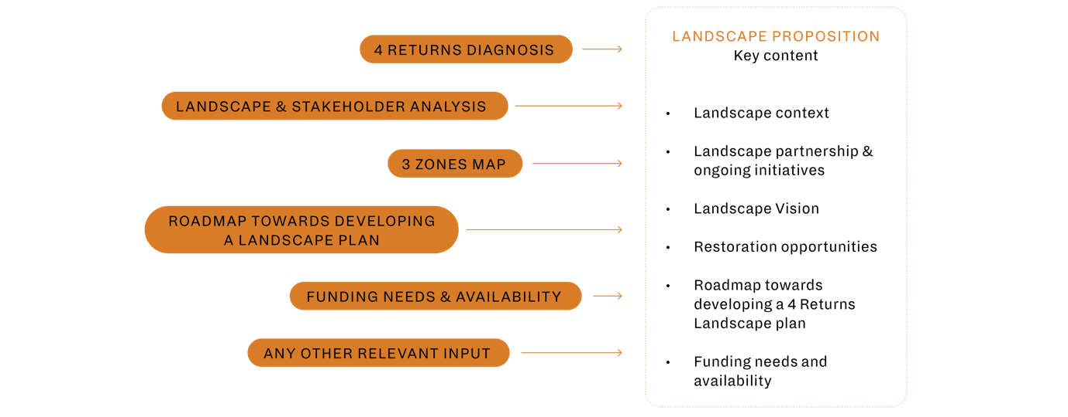

The landscape proposition (see figure above) combines earlier assessments and workshops, such as the 5 elements scorecard, 4 Returns diagnosis, the landscape and stakeholder analysis, carbon quick scan (if applicable), a description of the 3 zones and a stakeholder co-created landscape vision. Central to the landscape proposition is the landscape vision which gives a clear objective for the landscape, partners, and stakeholders. Both the vision and the proposition may be revised as a wider group of stakeholders become engaged and more information becomes available, but it is important to have a vision to keep clarity of purpose for the landscape and partners.

In addition to the landscape vision, other essential components include high-level information on the landscape context, the partnership and ongoing initiatives, key restoration challenges and opportunities, and a one-to-two-year roadmap that lists the activities and funding need to develop a landscape plan. A template and detailed guidance on creating a landscape proposition can be found on the 4 Returns platform.
Key uses of the Landscape Proposition
The landscape proposition includes a roadmap for developing a landscape plan and identifies what funds are needed and available. So, it can be used to:
  - Communicate restoration ideas to wider stakeholders, investors and policymakers to create 4 Returns impact in a landscape
  - Mobilise resources needed for the next development phase – mainly creating a stakeholder-owned landscape plan.
  - Inform an agreement between partners on the coordinated actions needed to create a landscape plan
  - Mobilise more stakeholders to support or join the landscape restoration process
  - Suggest short-term actions (one-to-two years) to develop a landscape plan that delivers a broadly shared landscape vision

Important considerations
  - The proposition is often written from the perspective of a limited number of key landscape partners and more stakeholders are likely to become involved over time.
  - Early actions can be included in the proposition, but activities might need adjusting as more stakeholders join the planning process.
  - Similarly, any emerging vision for the landscape should be broad at this stage so that more inclusive goals can be set later during the multistakeholder process.
  - Funding to develop a landscape proposition also should be flexible to allow for changes as both the vision and proposition become enriched by new stakeholders.
  - The proposition does not replace the landscape plan but is a useful basis for creating one.

How does a proposition feed into a Landscape Plan?
Remember, a landscape proposition includes a roadmap for developing a landscape plan and identifies what funds are needed and available. So, the proposition precedes but does not take the place of a more detailed plan. A 4 Returns landscape plan is a document that sets out your restoration activities aligned with the landscape vision. It builds on the landscape proposition and defines activities, targets, budget and finance sources over the long term. It is important to take time developing a landscape plan to ensure that it is co-created and agreed upon with stakeholders, with roles and responsibilities assigned. Developing a 4 Returns landscape plan from scratch can take between one and three years.
Template - Landscape Proposition (Total: maximum of 10 pages)
Title: Landscape Proposition for Landscape {name}
Introduction | General introduction of the organizations writing the landscape proposition, their vision and mission and relation to the landscape
1. Landscape context (Max 2 pages) | General characteristics  - Landscape boundaries  - Description current state of the 4 Returns [use or refer to 4R Diagnosis]  - Describe the 3 zones: where are the zones, what are the main activities, how do the zones interact? [use 3-zones exercise as input]  Landscape challenges (max 1 page)  - Key challenges including degradation problems (e.g. threats, root causes, future impact of climate change, social, environmental, and economic challenges) [use a.o. 4R Diagnosis as input]
2. Landscape partnership & ongoing initiatives (Max 2 pages) | Description of the landscape partnership [use a.o. 5E Scorecard as input]  - Key partners and their track-record  - Key landscape stakeholders by level of influence and interest  - High-level stakeholder map of partnership (or in existing projects)  Ongoing activities  - Overview of ongoing initiatives, projects and programs in the area (if available, include funding already allocated in the area)  - Overview of existing visions
3. Restoration opportunities  (Max 2 pages) | Restoration opportunities  - Inventory & identification of key opportunities: activities/interventions, restoration and regeneration opportunities, business related activities, investment opportunities [use a.o. 4R Diagnosis as input]  - Description of key challenges
4. Roadmap towards developing a 4R Landscape Plan  (Max 2 pages) | Roadmap for next 1-2 years to develop a full 4R Landscape plan  - Priority activities and timeline to set up a multi-stakeholder process and develop a 4R landscape plan  - Key activities/Interventions to be developed in the next phase (1-2 year): e.g. workshops, pilots, studies, stakeholder engagement, mobilisations, investor pitches, policy prepositioning, comms etc.  - Describe responsibilities and stakeholder involvement
5. Funding needs and availability | Describe the resource and funding needs and availability to set up a multistakeholder process to develop a 4R Landscape Plan
Appendices and references: | Please add all information that supports the proposition and references
* Some information may still not be available, will become during or as result of the landscape plan development process. It is important to ensure at least some high-level information on the landscape context, the partnership, and the roadmap to a landscape plan is outlined to enable effective communication with funders and other stakeholders.

